Skills for Care variable guide

* Calculating average total staff





Average total staff = (Y0 + Y1)/2 = (totalstaff Y1 – totalstarters + totallevers + totalstaff Y1)/2

= totalstaffY1 + ½(totallevers – totalstarters)

Turnover = total levers/average total staff



* Meaning of jr codes

- "jr" codes

Code Label

28 **Any job role**. This is the sum of all job roles submitted by the establishment.

29 **Any direct care role**. This is the sum of all direct care roles submitted by the establishment. (Note: this variable may be more directly related to service quality)



|  |  |  |  |  |  |  |  |  |  |  |
| --- | --- | --- | --- | --- | --- | --- | --- | --- | --- | --- |
| jr##flag | Does the workplace have staff records? | |  |  |  |  |  |  |  |  |
| jr##perm | Number of permanent staff employed. Based on staff records. | | |  |  |  |  |  |  |  |
| jr##temp | Number of temporary staff employed. Based on staff records. | | |  |  |  |  |  |  |  |
| jr##pool | Number of pool/bank staff employed. Based on staff records. | |  |  |  |  |  |  |  |  |
| jr##agcy | Number of agency staff employed. Based on staff records. | |  |  |  |  |  |  |  |  |
| jr##oth | Number of other staff employed. Based on staff records. | |  |  |  |  |  |  |  |  |
| jr##emp | Number of permanent and temporary staff (employees). Based on staff records. | | | |  |  |  |  |  |  |
| jr##work | Number of staff records. |  |  |  |  |  |  |  |  |  |
| jr##strt | Number of permanent and temporary staff that started in the previous 12 months. If totalstarters is 'not known' or not recorded, value is zero. | | | |  |  |  |  |  |  |
| jr##stop | Number of permanent and temporary staff that left in the previous 12 months. If totalleavers is 'not known' or not recorded, value is zero. | | | |  |  |  |  |  |  |
| jr##vacy | Number of permanent and temporary staff vacancies at the time of last update. If totalvacancies is 'not known' or not recorded, value is zero. | | | |  |  |  |  |  |  |

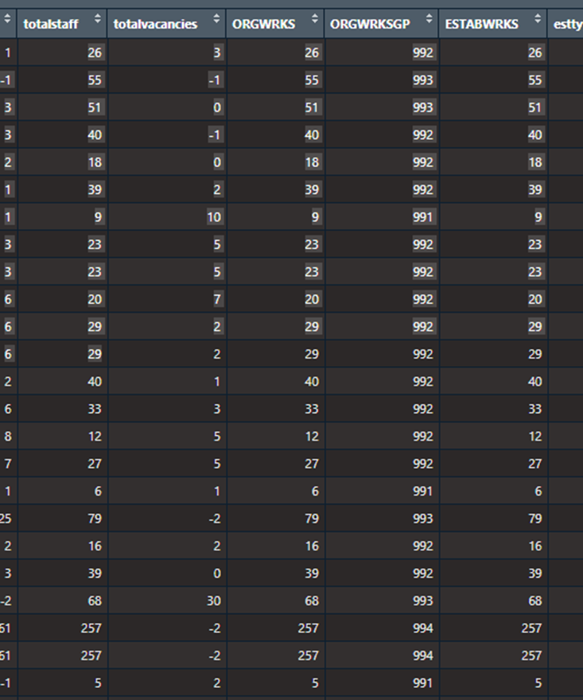

30 Any manager/supervisor role. This is the sum of all manager/supervisor roles submitted by the establishment.

31 Any regulated profession role. This is the sum of all regulated profession roles submitted by the establishment.

32 Any other roles. This is the sum of all other roles, those not included in groups 29,30 and 31, submitted by the establishment.

1 Senior Management

2 Middle Management

3 First Line Manager

4 Registered Manager

5 Supervisor

6 Social Worker

7 Senior Care Worker

8 Care Worker

9 Community Support and Outreach Work

10 Employment Support

11 Advice Guidance and Advocacy

15 Occupational Therapist

16 Registered Nurse

17 Allied Health Professional

22 Technician

23 Other care-providing job role

24 Managers and staff in care-related but not care-providing roles

25 Administrative or office staff not care-providing

26 Ancillary staff not care-providing

27 Other non-care-providing job roles

34 Activities worker or co-ordinator

35 Safeguarding and reviewing officer

36 Occupational therapist assistant

37 Nursing Associate

38 Nursing Assistant

39 Assessment officer

40 Care co-ordinator

41 Care navigator

42 Any Childrens/young peoples job role

* Vacancy?